9th International Conference on Computer Science and Computational Intelligence 2024 (ICCSCI 2024)
DEVELOPMENT OF AN AI-BASED WEB APP FOR RAPID COVID-19 DIAGNOSIS USING DEEP LEARNING
Abstract
To improve the speed and accuracy of COVID-19 detection, this study is focused on constructing a web-based artificial intelligence (AI) platform that uses X-ray images of lungs. In order to detect COVID-19 quickly, especially in its early stages, it blends Convolutional Neural Network (CNN) models such as ResNet50, VGG16 and Xception. Even where there are no apparent symptoms in the patients, the choice of an x-ray image is because it can be used to identify some common features of COVID-19. This consisted of positive cases for Covid-19 although they were also used to train CNN models. The resulting online application has been provided with a simple user interface designed for healthcare professionals at different levels of expertise. According to research results, the implemented CNN models achieve acceptable accuracy rates; whereas ResNet50 copes well with complex instances, VGG16 demonstrates good generalization ability and Xception performs well in many situations with high accuracy. It can therefore be argued that overall this internet-driven development will significantly boost the efficacy and dependability included in discovering Covid-19 diagnosis.

© 2024 The Authors. Published by ELSEVIER B.V.
This is an open access article under the CC BY-NC-ND license (https://creativecommons.org/licenses/by-nc-nd/4.0)
Peer-review under responsibility of the scientific committee of the 9th International Conference on Computer Science and Computational Intelligence 2024
Keywords: AI, CNN, COVID-19, X-Ray, Web Application.
- Introduction
The COVID-19 pandemic was discovered in Wuhan, China in December 2019; it has greatly affected various aspects of human society. As of 17 December 2020, according to WHO, 72,196,732 cases of COVID-19 have been registered worldwide. Out of this number, there were 1.630.521 deaths. Most cases were recorded in the Americas (30,925,241 Cases) as at December 17th ,2020 while America accounted for (22.603.335), Europe being third (11.468.106) Immediately after causing an impact on global health systems; the world community would feel both economic and social consequences associated with this outbreak that involved the whole globe.Ways to quickly handle and recover from pandemic effects are heavily dependent on research and development of new approaches [2] [5].

Rapid and accurate diagnosis is one vital part in responding to Covid-19 .In addition to standard diagnostic techniques like RT–PCR tests radiology scans can be important diagnostic tools for early detection and disease progression monitoring .Lung X-ray scans allow for visual determination of lung organ changes which may help identify pneumonia symptoms linked with covid-19 .[3]

The development of the technology of artificial intelligence (AI) has provided new possibilities for improving efficiency and accuracy in diagnosis through lung x-ray scans. This research focuses on convolutional neural network (CNN) algorithms, which are known to be effective in medical image analysis. The expectation by integrating AI technology into lung x-ray scan is that a faster, more accurate and reliable diagnosis solutions can be created.[1]

This study is aimed at developing an AI based web application for diagnosing COVID-19 through lung x-ray scans. ResNet50, VGG16 and Xception are among the top CNN models that this application will use. With emphasis on early detection and high level of accuracy, this application is expected to be a valuable tool in fighting the pandemic globally.

In respect to the aforementioned objective, the methodology section includes several crucial steps: collecting datasets containing different cases of lung X-rays related to COVID-19 as well as others; training CNN models using these datasets; implementing them in a web-application. In designing this web-application there should be provision for a user-friendly interface such that medical professionals accessing diagnostic results can comprehend them with ease.

To verify whether this application can diagnose COVID-19, performance evaluation will be carried out using different data sets. Detailed analysis will also be performed to enable understanding the pros and cons of each CNN model and to give a deeper perspective about possible implementation of this application in relation to COVID-19 diagnosis.

The purpose of this study is to make a significant contribution toward enhancing the diagnosis capacity for COVID-19 by employing artificial intelligence in lung X-ray scans. The outcome of this would be a web-based application that would help health care providers deal with challenges posed by this pandemic. By merging AI technology and lung x-rays, hopes are high towards better identification and management of COVID 19 cases as well as an effective approach that contributes positively to global efforts against this healthcare emergency.

- Related Works
Ever since the COVID-19 virus outbreak in December 2019, there has been an influx of academic researches focusing on the computer-assisted detection of COVID-19. These studies have pursued different approaches, with a notable focus on machine learning (ML) and deep learning (DL) techniques such as deep convolutional neural networks (CNNs) used for analyzing chest X-ray and CT images related to COVID-19 diagnosis.
The first group of studies by Hemdan et al unveiled their proposed DL model called COVIDX-Net which yields impressive results using X-ray images, especially VGG19 and DenseNet201 models at 90% accuracy. Similarly, Barstugan et al suggested a conventional based learning approach using CT images that led to an exceptional classification of 98.77% accuracy with support vector machine (SVM). Another important work was done by Wang and Wong who designed COVID-Net, a DL architecture particularly focused on chest X-ray images giving an accuracy of 83.5%. Additionally, Maghdid et al improved upon this aspect by employing CNN framework resulting in an automatic diagnosis of COVID-19 pneumonia with an accuracy rate of 94.00% [6].
In another set of works, Computer-Aided Detection (CAD) System was designed for detecting or diagnosing COVID-19 with promising accuracies comprising up to 97.40% using DL algorithms as well as chest X-ray imaging. In addition, several studies have examined the effect of ACR Lung-RADS on CT lung screening which has led to a reduction in false positive and false negative outcomes. Furthermore, they looked at factors affecting how often RT-PCR results were positive and this showed that there is an association between COVID-19 relapse and particular pulmonary features.
The third category of papers discussed identification of COVID-19 using symptoms and chest X-ray images. ML and DL algorithms such as gradient boosting models, CNNs, ensemble stacking models with LSTM, GRU, SVM etc., were used here. Moreover, learning from pre-trained models like VGG16, ResNet50 and Concat_CNN was also common for chest X-ray images resulting into remarkable accuracy levels when it comes to COVID-19 detection.[1]
In conclusion, these studies present a comprehensive coverage of different methodologies and techniques employed in detecting COVID-19 ranging from traditional ML approaches to advanced DL models thus exploiting various imaging modalities as well as symptom data that demonstrate notable achievements in computer aided diagnostic (CAD) systems for infectious diseases.
- Methodology
The present research employs a structured approach to develop a web application based on Artificial Intelligence (AI) that can diagnose COVID-19 through lung X-ray scanning. Following is the overview of steps in details for successful application development:

  - Collection of Dataset

The initial step involves collection of dataset of Lung X-ray comprising COVID-19 cases and other cases. It was obtained from reliable sources in the field of medicine and contains pictures showing how diseases affect the lungs. This data is an essential basis for training CNN models.

  - Training CNN Model

Convolutional neural network (CNN) models, including ResNet50, VGG16, and Xception are trained using this compiled dataset. During this process, we divide the dataset into training set as well as validation set to ensure generalization of our model. In addition it is possible to utilize transfer learning methods that use information acquired by any previous models on related tasks.

  - Development of Web Application

The following step after completion of model training is development of web application. The user interface is designed to be usable so that users can easily upload lung-x rays images quickly. By implementing these CNN models at the backend side, we make sure that analysis process becomes more efficient and faster.

  - Testing and Evaluation

A separate dataset from the one used during training is applied to assess the web application. It includes several lung X-ray pictures, some of which show Covid-19 while others do not. The measurement of accuracy, sensitivity, specificity and other evaluation parameters are carried out to evaluate performance.

  - Results Analysis

An in-depth analysis of test results was carried out in order to understand how each CNN model performed relative to others. This exercise involved assessing what each model was good at as well as its shortcomings in relation to diagnosis of COVID-19 through lung X-ray scans.

  - Optimization

The web application and CNN model can be improved depending on the findings obtained from this analysis. It involves recalibrating the model parameters, adjusting algorithms and optimizing the application interface leading to more accurate predictions with quicker feedbacks. In order for all stages such as data collection to optimization are conducted meticulously by following scientific principles, a method was employed that is guaranteed both reliable and effective AI technology use in COVID-19 detection solution through lung X-Rays scanning
- Results And Discussion
The web application underwent a series of tests on a lung X-ray dataset, consisting of 2482 images, with 1252 images positive for COVID-19 and the rest negative. In analyzing the performance of CNN models, ResNet50 shows its superiority. ResNet50 utilizes the concept of “residual blocks,” which allows information to jump across multiple layers at once. This is useful for addressing the “vanishing gradient” problem and supports training on deeper models. The use of ReLU activation functions across layers and Global Average Pooling (GAP) at the end of the ResNet50 architecture plays a key role in improving feature understanding.

VGG16, with 16 3x3 convolution layers, shows consistency in both positive and negative cases. VGG16's nested architecture allows it to extract complex feature hierarchies along with levels of depth. The use of max-pooling technique after each convolution layer helps maintain dominant feature representation. Meanwhile, Xception, with its "depthwise separable convolution" approach, achieves high accuracy by minimizing the number of parameters and using multiple branches to capture features at various scale levels.

  - ResNet50 (Residual Network)

● Convolutional Layers:
ResNet50 starts with convolutional layers to capture initial features in lung X-ray images. This convolution uses filters to detect patterns and structures in the image.
● Residue Block:
A key concept in ResNet50 is residual blocks, where information can jump across multiple layers at once. This helps overcome the “vanishing gradient” problem and supports deeper model training.
● ReLU Activation Function:
After each convolution, the ReLU activation function is applied. ReLU helps in identifying patterns and structures in images by converting negative values ​​to zero.
● Global Average Pooling (GAP):
At the End of the architecture, Global Average Pooling (GAP) is performed. GAP averages the convolution results on each channel, producing a feature vector with smaller dimensions, representing the image holistically.
● Output Layer:
The results of the GAP are directed to the output layer with a softmax activation function to produce class probabilities (COVID-19 positive or negative).
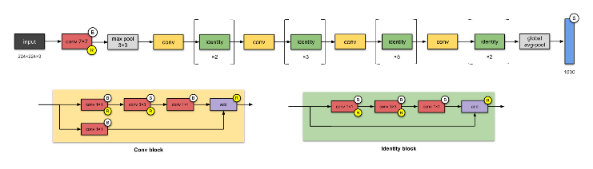
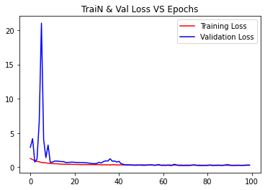

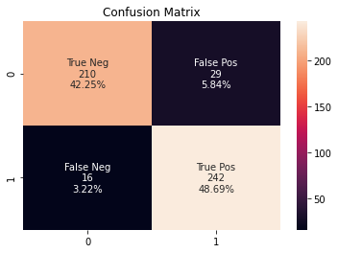
ResNet50 is particularly effective in analyzing lung X-ray images. Residual blocks allow the model to focus on critical features such as infiltration in the lung. The ReLU activation function helps identify patterns, while GAP constructs a feature vector that represents the image comprehensively.

  - VGG16 (Visual Geometry Group)

● Convolutional Layers:
The VGG16 multilevel architecture consists of 16 3x3 convolutional layers. Each layer is responsible for extracting features at increasingly higher levels. Initial convolution is used to detect initial features such as edges and corners in the image.
● Max-Pooling Technique:
After each convolution layer, a max-pooling technique is performed to reduce the image dimensions and maintain the representation of the main features. This helps the model in understanding the hierarchical structure of the features.
● ReLU Activation Function:
The ReLU activation function is applied after each convolution to speed up convergence during training and improve understanding of patterns in the image.
● Output Layer:
After the convolution and max-pooling process, the results are directed to the output layer with a softmax activation function to produce class probabilities.

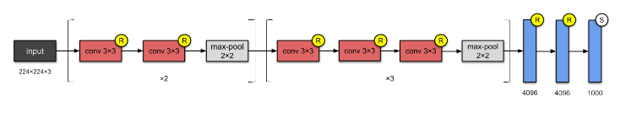
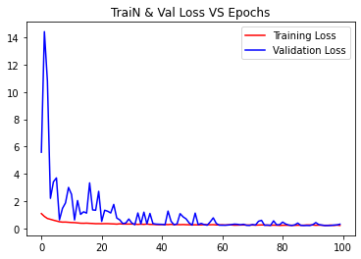

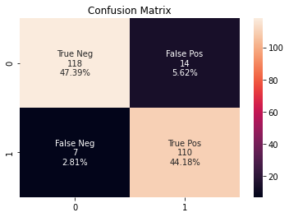
VGG16 progressively understands increasingly complex features in lung X-ray images. Max-pooling helps the model to maintain dominant features, making it easier to identify important patterns in the image.

  - Xception (Extreme Inception)

● Depthwise Separable Convolution:
Xception uses a "depthwise separable convolution" approach, which breaks down convolution into two separate stages: spatial convolution and channel convolution. Spatial convolution is used to capture initial features in the image.
● Multiple Branches:
Xception uses multiple branches to capture information at different levels. This approach helps the model in identifying complex patterns in images.
● ReLU Activation Function:
After each convolution, the ReLU activation function is applied. It helps in identifying patterns and structures in images by converting negative values ​​to zero.
● Output Layer:
The results of multiple branches are directed to the output layer with a softmax activation function to produce class probabilities.

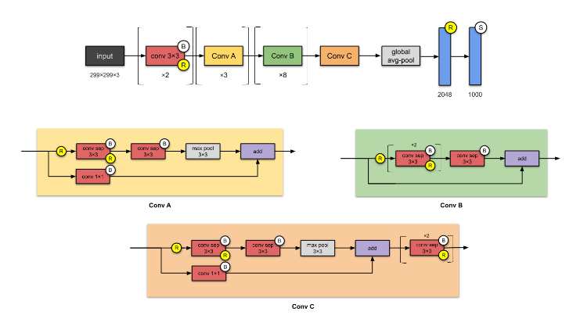
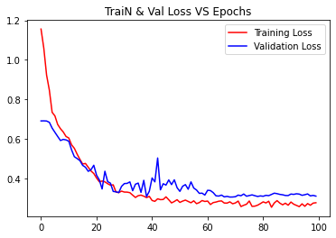

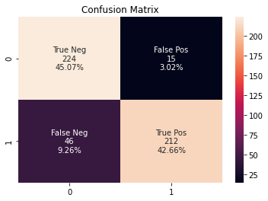
Xception, with depthwise separable convolution, is very efficient in analyzing lung X-ray images. This approach allows the model to extract important features with fewer parameters, while multiple branches enrich the model's understanding of various aspects of the image. In comparison with human interpretation, the web application demonstrated equivalent levels of accuracy. The application's diagnostic speed is its main advantage, providing prediction results in the time span of 1-6 seconds. Nonetheless, human interpretation remains important for validation and deeper medical context.

Test results and analysis show that this web application has significant practical implications in supporting COVID-19 diagnosis efforts. With a good level of accuracy and acceptable time prediction, this application can be integrated into existing health systems, providing a tool for medical personnel for early identification of COVID-19 cases. The average confidence score of 0.7-0.9 provides an indication of the model's level of confidence in each prediction. Transfer learning techniques can include the use of pre-trained models to improve model performance on limited datasets.

- Conclusion and Future Work

COVID-19. This study concludes that, through x-ray analysis of the lungs, this software may be referred to as an important supplementary tool useful in detecting COVID-19 at its earliest stage. The efficiency of every CNN algorithm in enhancing diagnostic performance reveals the great promise it holds for practical use.
On a general note, this project is a significant stride towards addressing the issues related to the global pandemic. Nevertheless, using this application should be accompanied by human interpretation for accurate and contextual diagnostic results. This program will continue to perform better even in subsequent versions so as to enhance service delivery in public health. Such a research has successfully come up with AI-based application that makes it easier and more affordable to test COVID-19 among people. Integrating this application into existing medical systems would aid early detection of Covid-19 by medical practitioners. COVID-19 cases, ultimately contributing to the global effort to combat this pandemic

References
- AlMohimeed, A., Saleh, H., El-Rashidy, N., Saad, R. M. A., El-Sappagh, S., & Mostafa, S. (2023). Diagnosis of COVID-19 Using Chest X-ray Images and Disease Symptoms Based on Stacking Ensemble Deep Learning. Diagnostics, 13(11). https://doi.org/10.3390/diagnostics13111968
- Azad, A. K., Mahabub-A-Alahi, Ahmed, I., & Ahmed, M. U. (2023). In Search of an Efficient and Reliable Deep Learning Model for Identification of COVID-19 Infection from Chest X-ray Images. Diagnostics, 13(3). https://doi.org/10.3390/diagnostics13030574
- Islam, A., Stea, G., & Rahman, K. M. (n.d.). COVID-19 Cases Detection from Chest X-Ray Images using CNN based Deep Learning Model. In IJACSA) International Journal of Advanced Computer Science and Applications (Vol. 13, Issue 5). www.ijacsa.thesai.org
- Manivel, V., Lesnewski, A., Shamim, S., Carbonatto, G., & Govindan, T. (2020). CLUE: COVID-19 lung ultrasound in emergency department. EMA - Emergency Medicine Australasia, 32(4), 694–696. https://doi.org/10.1111/1742-6723.13546
- Mitchell, W. B. (2020). Thromboinflammation in COVID-19 acute lung injury. In Paediatric Respiratory Reviews (Vol. 35, pp. 20–24). W.B. Saunders Ltd. https://doi.org/10.1016/j.prrv.2020.06.004
- Saygılı, A. (2021). A new approach for computer-aided detection of coronavirus (COVID-19) from CT and X-ray images using machine learning methods. Applied Soft Computing, 105. https://doi.org/10.1016/j.asoc.2021.107323
- Shahin, O. R., Alshammari, H. H., Taloba, A. I., & El-Aziz, R. M. A. (2022). Machine Learning Approach for Autonomous Detection and Classification of COVID-19 Virus. Computers and Electrical Engineering, 101. https://doi.org/10.1016/j.compeleceng.2022.108055
- Dwaipayan05. 2021. CovCNN-WebApp. https://github.com/dwaipayan05/CovCNN-WebApp
- Dwaipayanmunshi2001. 2022. Detecting COVID-19 From Chest X-Ray Images using CNN. https://www.geeksforgeeks.org/detecting-covid-19-from-chest-x-ray-images-using-cnn/.
- pawangfg. 2023. VGG-16 | CNN model. https://www.geeksforgeeks.org/vgg-16-cnn-model/.
- Plameneduardo. 2020. SARS-COV-2 Ct-Scan Dataset. https://www.kaggle.com/datasets/plameneduardo/sarscov2-ctscan-dataset.
- The MathWorks, Inc. 2017. ResNet-50 convolutional neural network. https://www.mathworks.com/help/deeplearning/ref/resnet50.html.
- The MathWorks, Inc. 2019. Xception convolutional neural network. https://www.mathworks.com/help/deeplearning/ref/xception.html.

